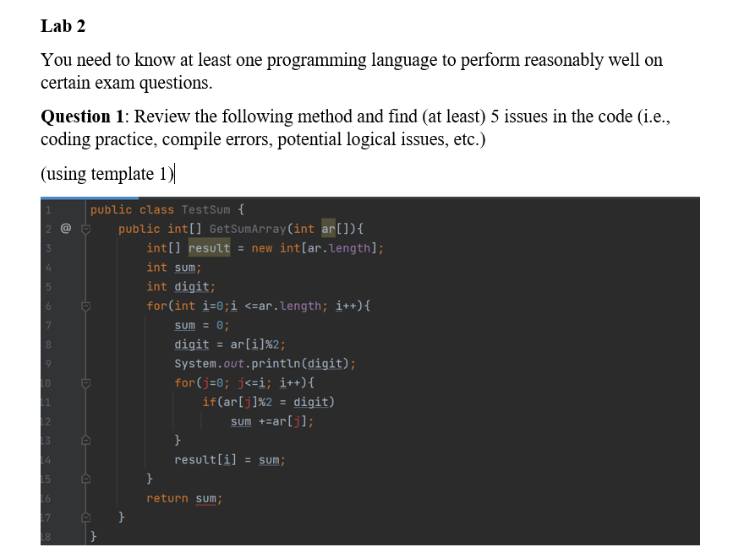

1. The loop for(int i = 0; i <= ar.length; i++) should be for(int i = 0; i < ar.length; i++). Using <= causes the loop to access an index out of bounds in the last iteration.
2. The inner loop for(j = 0; j <= i; i++) is missing the type declaration for j and incorrectly increments i instead of j.
3. The line if(ar[j]%2= digit) should use == for comparison, not = for assignment.
4. The method signature specifies that it returns an int[], but it returns sum which is an int.
5. The variable digit is printed before any validation check, which might not be necessary for the logic and should be handled properly.
6. **Method Visibility and Naming Convention:**

* The method and class naming conventions do not follow standard Java naming practices. The method name should be in camelCase (e.g., getSumArray), and the class name should be in PascalCase (e.g., TestSum).

**Question 2**: Create a TDD project, which test PrintEvenNumbers class with array of integers number, the class just prints all integers which are less than a given integer.